Appendix A

RAMP-TRIM Users Manual

Getting to Know RAMP-TRIM
and
Basic RAMP-TRIM Operations

United Nations Children’s Fund
3 United Nations Plaza
New York, New York 10017

Appendix A

Getting to Know RAMP-TRIM

Table of Contents

Introduction 4
1.1 An example of a hierarchy of Record Types 4
1.2 The Benefits to You 4
1.3 5
Basic RAMP-TRIM Operations 6
1.4 TO LOGON RAMP-TRIM 6
1.5 Lock RAMP-TRIM 6
1.6 Menu 7
1.7 Toolbar 7
1.8 Status Bar 7
1.9 KwikSelect Fields 7
1.10 Drop Down Lists 8
1.11 Combination Drop Down List and KwikSelect 8
1.12 Spell Check 9
1.13 Selector Dialogue 9
1.14 Active and Inactive Data Fields 9
1.15 Hierarchical Tree 10
1.16 Search Results 10
1.1.1 The Record List Pane 11
1.1.2 The Record View Pane 11
1.17 Customising the View Pane 11

Figure 1. TRIM Lock Screen 6
Figure 2. TRIM Menu & Task Bar 7
Figure 3. Tool Bar 7
Figure 4. Status Bar 7
Figure 5. Kwik Select 8
Figure 6. Drop Down List 8
Figure 7. Combination Drop Down List and KwikSelect 9
Figure 8. Spell Check Selector Box 9
Figure 9. Selector Dialogue Box 10
Figure 10. Hierarchical Tree for Locations 10
Figure 11. Search Results Window 11
Figure 12. Customize the Veiw Pane 12

Introduction
This Annex will explain to you what a Record is. You will also learn the difference between a Record and a Record Type.

A record can be anything. Really!!! The most common kinds of records are Files and Documents, however there is nothing stopping you registering magazines, boxes, CDs, books, even your collection of shoes and thus they are also records.

When you install RAMP-TRIM, it knows nothing about Files, or Folios, or Correspondence or any other types of Records. YOU have to tell RAMP-TRIM what sort of records you have and what information they are to contain.

This is what Record Types are all about. RAMP-TRIM can reflect the different types of records that may occur within your organization, but first you must set these up as separate Record Types.

RAMP-TRIM provides a starting point for you when defining your Record Types. Every Record Type has to be allocated a Level within a hierarchy:

The Level is a unique number that you allocate to every Record Type. This is to signify the place that the Record Type has within the record hierarchy of your organization.

An example of a hierarchy of Record Types
The following is an example of a typical implementation of RAMP-TRIM Record Types:
Files (Level 3), contain file attachments and incoming correspondence
File Attachments (Level 2), contain glossy brochures etc. that are sometimes put into files, or sometimes treated independently

Folios (Level 1), are the incoming and outgoing correspondence which is put into files.
With the example above, a level 3 File can contain level 2 File Attachments and level 1 Folios. Level 2 File Attachments can only contain level 1 Folios. The level 1 Folios cannot contain anything because they are the "lowest" Record Type within the system.

The Benefits to You

You will encounter the KwikSelect fields throughout RAMP-TRIM. They consist of a text field and a button on the right hand side, with a yellow folder painted on it. Clicking on the button will show you a list from which you can pick the information to fill the text field or will bring up a RAMP-TRIM Search.
The information in the list is user defined, which means that either your System Administrator or you can determine what choice there is.

You don’t need to access the list every time you fill in a KwikSelect field. It is possible to just type a value into the text file. However, RAMP-TRIM will verify that there is a matching value in the list.
If you know the first few characters of the value that you want to enter in the field, you can enter them before Attachments accessing the list. This will force RAMP-TRIM to show you the list from whatever

point in the list these characters appear. This helps you avoiding extensive scrolling. Access the KwikSelect list without the mouse using the [alt - ↓] keys.

This hierarchy model allows RAMP-TRIM to reflect your "real-world" environment. RAMP-TRIM fits into the way you do things; you don't have to fit into the way RAMP-TRIM works.
The ability of RAMP-TRIM to contain records within other records eg. correspondence within files, means that performing a task against a file (eg. a movement) can also apply to the contained correspondence at the same time, making RAMP-TRIM a powerful tool when Record Types are well structured.
Unity: In one sense, regardless of the Record Type, all records can be treated equally, so that performing a task on a record eg. File, File Attachment, Folio etc. is the same for any Record Type you define. This makes RAMP-TRIM easy to learn and use.
Diversity: The hierarchy model allows you to maintain distinction between each record series so that they can be treated differently, if required.

Annex - Questions:

- A record:
a) Can be anything
b) Can always contain another record
c) Is a round thing with a hole in the middle.

- Each record type:
a) Should have a unique numbering pattern.
b) Must be assigned to a Record Type Level.
c) Is an entry for an individual real world document or file.

3. If I have 3 record types with the levels 2, 4 and 6:
a) I can put a record of the level 2 into one of the level 6
b) I can put a record of the level 4 into either a level 2 or a level 6.
c) I get terribly confused
d) I can always put a lower level record into a higher level record.

Basic Operations

LOGON
This section will familiarise you with the most common components of RAMP-TRIM.

Double Click on the RAMP-TRIM 4.3 icon
At User Name type your user name then TAB to Password and type your password.
If you need to log into another database choose it from the drop-down list.
Choose OK.

Passwords are case sensitive. Check your CAPS Lock key if you fail to log in yet believe your user name and password are correct. Access the Logon screen using the Folder Button or select Login from the File.

Lock RAMP-TRIM

The Lock RAMP-TRIM feature will enable you to stay logged into RAMP-TRIM but lock the application so unauthorised users cannot access RAMP-TRIM whilst you are away from your desk. Once locked, RAMP-TRIM cannot be accessed until the lock has been deactivated. This has no affect on any other application or program. The Locking Function is activated from the File Menu – Lock RAMP-TRIM. When this function has been selected the following dialog will appear:

This dialog box will remain visible until you remove the lock. To unlock RAMP-TRIM, simply type in the your password, press OK and the application will then become available. Once the Locking Function has been applied, it can only be removed by the currently locked in user or by a System Administrator. The Log Out button will close RAMP-TRIM.

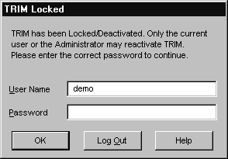
Figure 1. TRIM Lock Screen

Menu
Each one of the menu words represents a Task series. You can click on them to display a list of options. To access the menu options without a mouse, press the Alt key on your keyboard followed by the underlined letter of the desired menu. To select a menu option, click on it, or type the underlined letter on the keyboard. The Edit Menu, Navigate Menu, Task Menu and Browse Menu will only be available when you have records displayed.

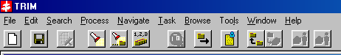
Figure 2. TRIM Menu & Task Bar

Toolbar
The Toolbar contains buttons that represent different options of the menus. Colored buttons are available to you, greyed out buttons will become available when it makes sense for them to be used. To find out what a button does, move the mouse pointer on top of it and a pop-up description will appear or read the description in the status bar.

Figure 3. Tool Bar

Status Bar
If you move your mouse pointer on top of a button in the Toolbar, the Status Bar will display a short description of the buttons function. At other times some information about your current session will be displayed (eg. User Name, Database Name, Num Lock etc.).

Figure 4. Status Bar

KwikSelect Fields
You will encounter the KwikSelect fields throughout RAMP-TRIM. They consist of a text field and a button on the right hand side, with a yellow folder painted on it. Clicking on the button will show you a list from which you can pick the information to fill the text field or will bring up a RAMP-TRIM Search.
The information in the list is user defined, which means that either your System Administrator or you can determine what choice there is.

You don’t need to access the list every time you fill in a KwikSelect field. It is possible to just type a value into the text field. However, RAMP-TRIM will verify that there is a matching value in the list.
If you know the first few characters of the value that you want to enter in the field, you can enter them before accessing the list. This will force RAMP-TRIM to show you the list from whatever point in the list these characters appear. This helps you avoiding extensive scrolling. Access the KwikSelect list without the mouse using the [alt - ↓] keys.

Figure 5. Kwik Select

Drop Down Lists

Drop down lists consist of a field containing some text and a button on its right hand side with a black arrow painted on it. The main difference between the KwikSelect and the Drop Down Lists is that the drop down list does not let you just type a value in to the text field. The list consists of a set of values not necessarily in alphabetical order. To quickly find the value you are looking for, type its first character. If the default value in the field is highlighted, you can type the first character of your desired value without dropping down the list. If there are several values beginning with the same character keep pressing the key until you are presented with the desired one.

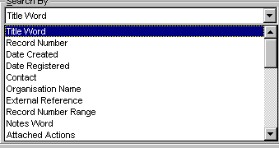
Figure 6. Drop Down List

Combination Drop Down List and KwikSelect

When a Drop Down List and a KwikSelect are both on an Edit Box
[Alt – ↓] will reveal the Drop Down List and [Alt - →] will access the KwikSelect

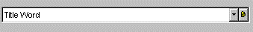
Figure 7. Combination Drop Down List and KwikSelect

Spell Check

On free text fields, such as Record Title or Notes, a spell checking facility is available by pressing the Spell Check Button. The Spell Check Button is normally located to the right of a free text field and has a tick painted on it. The Alt - ↓ key will also start the Spell Checker.


Figure 8. Spell Check Selector Box

Selector Dialogue

Selector Dialogues are used to determine what information you would like to have listed in the View Pane on various windows in RAMP-TRIM. You will always be presented with a list of available items in the left box and a list of active items in the right box. Pressing the buttons between the two boxes will move the highlighted item from one box into the other in direction of the arrows. The item will be inserted below the highlight in the target box.

To make it easier to find an item in either of the boxes, type its first letter. To change the order of the active items you can use the Up or Down buttons. Double clicking on an item quickly moves it from one box into the other.

In several places in RAMP-TRIM you will be confronted by hierarchical trees. If you click on a plus sign, the hierarchy will be expanded one level. If you click on a minus sign, the lower branch will be collapsed.

Active and Inactive Data Fields

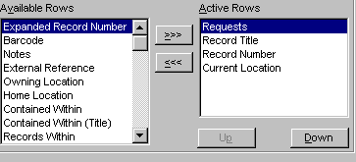
Figure 9. Selector Dialogue Box

Hierarchical Tree
☑ Tip You also have the following keyboard options to choose from:

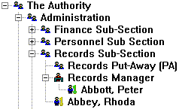
Figure 10. Hierarchical Tree for Locations

[*] key on number pad = expand the highlighted branch completely
[+] key on number pad = expand the highlighted branch only one level
[-] key on number pad = collapse the highlighted branch
[ctrl] and the [-] key on the number pad = collapses the whole hierarchy.
All of the above keyboard options can also be accessed by clicking the right mouse button on any branch.

If the Hierarchical Tree is not showing the correct information, use the Search Button to find the correct data.

Search Results

The Search results are presented in two different windows. The Search View Pane (below) and Search List Pane (above).

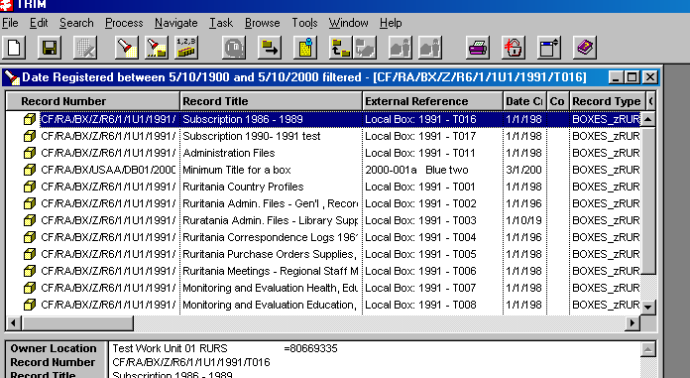
Figure 11. Search Results Window

The Record List Pane
The Record List pane displays all the Search Results. The Scroll Bar will enable you to see all Records that match your search criteria. The Record List pane can be customised under Tools – Option in the category of Record List Pane. The Count function under the Search Menu will tell you how many records a Search has returned.

The Record View Pane
The Record View pane displays specific information for the currently highlighted record. You can customise the view pane to see specific information for a particular Record Type. The Scroll Bar will enable you to see all information in the Record View Pane.

Customising the View Pane

The Record View Pane can modified using a Short Cut Menu. Highlight a Record in the Record List Pane. Place your mouse into the Record View Pane and click the right hand (secondary) mouse button. The Short Cut Menu will appear and select Options. The View Pane Options selector dialog box will be displayed.

Highlight one of the options within the Available Fields and press the >>> button to move it in to the Active Fields. Move across all required fields into the Available Fields. The modifications to the View Pane will be applied to all Records of that Record Type. If you wish to remove any active fields, then highlight the option in the Active Fields list and choose the <<< button. This will move the option back into the Available Fields list. Fields in the Active List will not appear in the Available fields List.

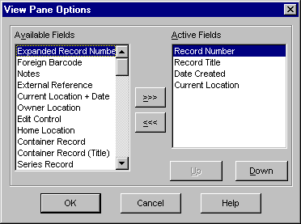
Figure 12. Customize the Veiw Pane

Annex - Questions:

- When logging in to RAMP-TRIM:

a) The User Name is case sensitive
b) Only the Password is case sensitive
c) Both of the above are case sensitive

- KwikSelect Lists:

a) Are usually just a short Drop Down list of different options to fill in a field
b) Should be accessed after typing a prefix into the field
c) Use a funny way of spelling quick

